BIOLOGICAL SAMPLING FOR 2021
Biological sampling for 2021
FIELD EQUIPMENT for each observer
caliper
-durometer (2)
-sampling sheets
SAMPLING METHODS
The supervisor of the observers (Consultant Company) will advise which vessels the observers have to sample, as requested by DFO. The observers will have to conduct two types of sampling: a) before discarding, and b) after discarding.
These two types of sampling should be done continuously for the entire fishing activity for a maximum number of traps as possible. These two samples have to be done to make a ratio of two samples before discarding to one sample after discarding for the entire fishing activity.
Before discarding
Each sampling has to be done by the following manner:
1. Randomly select 40 male crabs.
2. Measure the forty (40) male crabs selected and give them to the crew after measurement.
After discarding
- A randomly selected twenty (20) male crabs
- Measure the twenty (20) male crabs.

INFORMATION TO BE COLLECTED
An explanation of the information to be taken is as follows: (see appendix 1 - Sampling sheet).
The information on the total number of male crabs in the traps, the immersion time and the missing legs, filled in black on the sampling sheet, are not required for the 2021 sampling protocol to maximize the effort in sampling more traps.
TRIP NUMBER: The company provides that number to the observer.
DATE: The date of sampling.
PAGE: Page number / total number of pages per trip.
VRN, VESSEL, OBSERVER: Each observer is to place his / her name, the vessel registration number (VRN) and the name of the boat on all of the sampling sheets.

AREA: 12 - Area 12, 18, 25/26
19 - Cape Breton 19
12E - Area 12E
12F - Area 12F
POSITION: The position and the depth where the trap is sampled. The position has to be in latitude / longitude (degrees, minutes, to one hundredth of a minute).
DATA TYPE: 1 - Landing (after discarding)
2 - Trap at sea (before discarding).
TYPE OF TRAP AT SEA: See company code.
SPECIES: See company code.
LANDED WEIGHT (KG): Total weight of the landing in kilograms (kg).
TRAP NUMBER: This is the number of the trap sampled and must be written on each sampling sheet. For a sample after discarding only (data type 1-Landing), indicate 99 for the first sample taken and backward by 1 for the subsequent samples (example: 98 for the second sample, 97 for the third sample etc…).
DEPTH: The depth of the trap sampled should be noted in meters (m).
SEX: Only male crabs are measured. Male (M).
CARAPACE WIDTH, CLAW HEIGHT: See appendix 2.
CARAPACE CONDITION: See Appendix 3.
DUROMETER: See appendix 4.
REMARKS: Any abnormal observations and / or comments.

Appendix 1. Example of an at-sea observer sampling form.
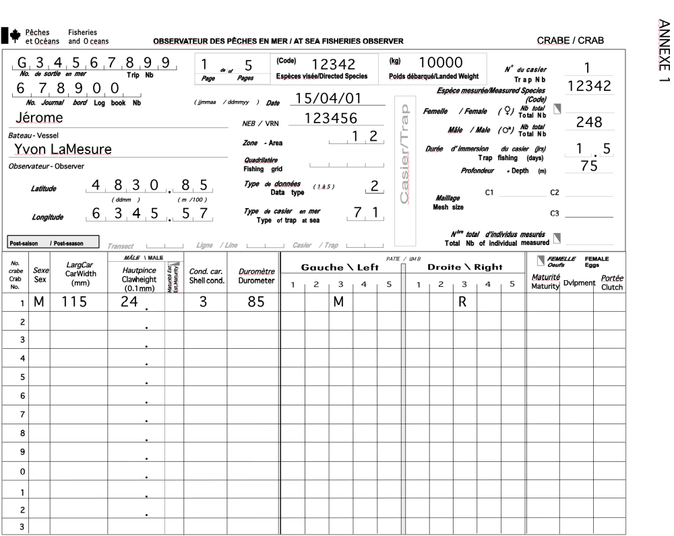
Appendix 2. Description of carapace width and claw height measurements.
Appendix 3. Descriptions of each carapace condition with identification keys.
Condition 1 – New soft
This recently molted crab has a carapace that is soft or firm but flexible, the claw is easily broken under thumb pressure. The dorsal surface is light brown and the ventral one is transluscent. Iridescence is apparent at different spots on the carapace. Neither wear nor scars are shown on the carapace, spines and dactyls are very sharp. The carapace is very clean, no trace of epibiontes (moss, balanus, spiroide and leech eggs) are visible at this stage. The crab stays in that condition for approximately three months and during that period of time, the meat yield is at its lowest level.
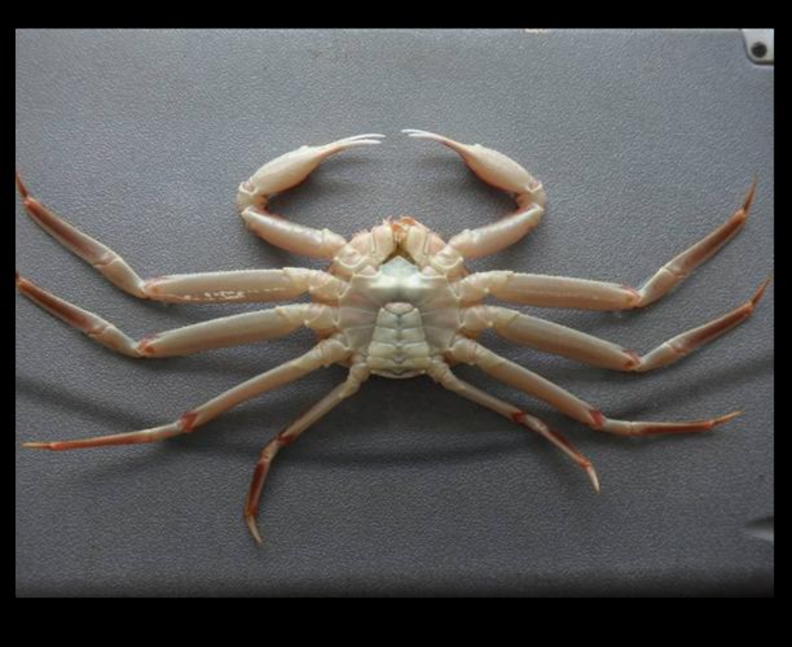
Condition 2 – New hard
This crab molted during the current year, the carapace is rigid and the claw is hardly broken under thumb pressure. The dorsal surface of the carapace is light brown and underneath is white and opaque, appearance of iridescence at multiple places on the carapace. No appearance of wear or scratch, spines are really sharp. The crab is clean and the carapace may have presence of epibiontes (moss, balanus, spiroide and leech eggs). This condition starts around three months after the crab molt and last for approximately 9 months. During that period, the meat yield becomes low to medium.
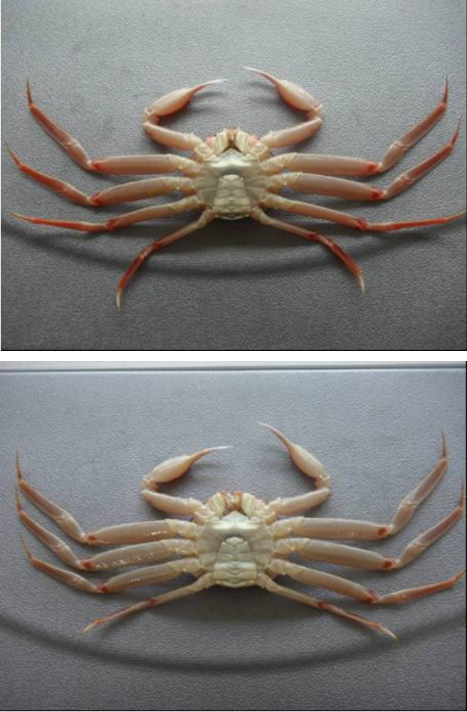
Condition 3 – Intermediate
This crab molted more than one year ago. The carapace is hard and firm, the claws are unbreakable under thumb pressure. The dorsal surface of the carapace is light brown and the ventral surface is yellow-beige, iridescence is only showing in very few places on the carapace. Spines and dactyls are still sharp but signs of wear are starting. Scars are visible on the ventral surface. The meat yield is at its maximum level. This crab has very few or no moss spot (bryozoans) on the carapace. Some other organisms (balanus and / or spiroide) are generally present.
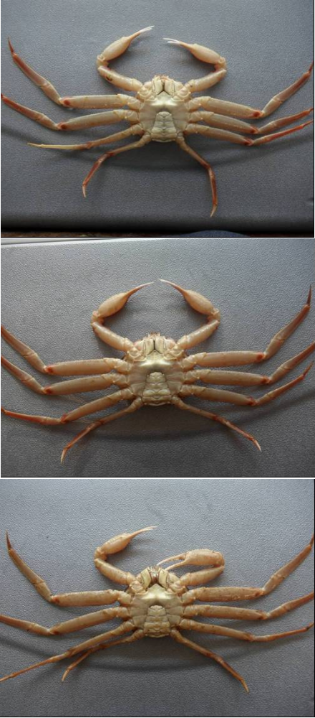
Condition 4 – Old
The carapace is hard and firm and the claws are unbreakable by simple thumb pressure. The dorsal surface is dark brown and the ventral surface is yellowish brown, no iridescence. Signs of wear and ageing are evident; there are a lot of scars and scratches on the carapace. Spines and dactyls are rounded. The organisms (moss, balanus and / or spiroide) are always present.
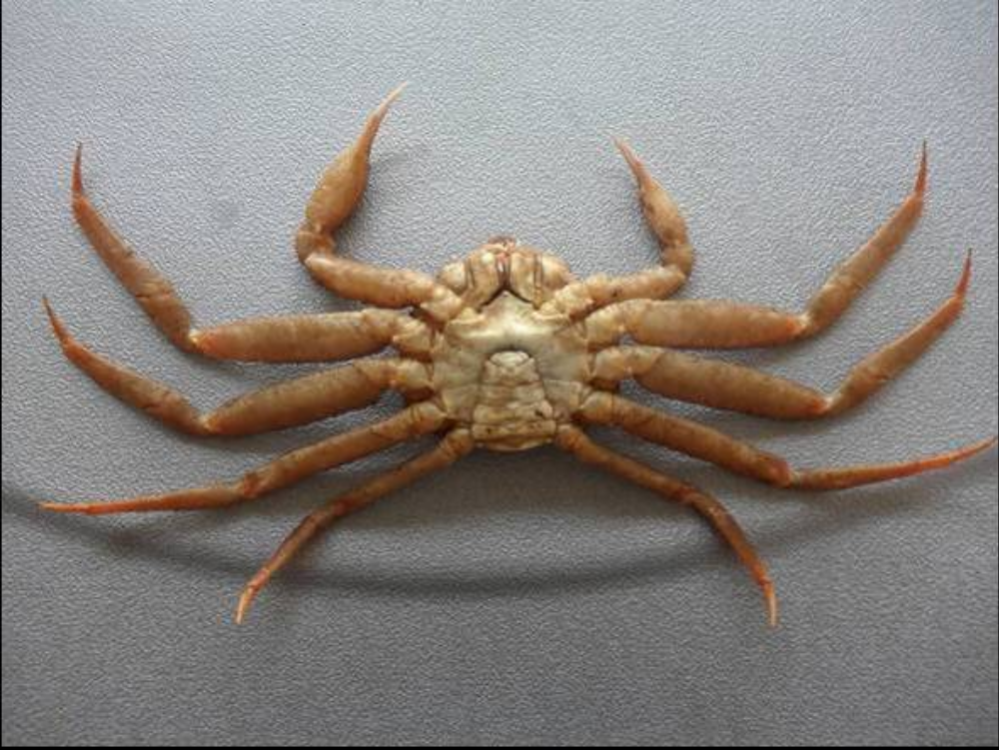
Condition 5 – Very old
The carapace is dirty and claws and articulations are softening due to decalcification. The dorsal and ventral surfaces are dark brown, no iridescence. Scars are everywhere on the carapace. Appearance of wearing is widespread on the carapace, spines and dactyls are rounded and sometime damage. The organisms (bryozoa, balanus and spiroide) are always present.
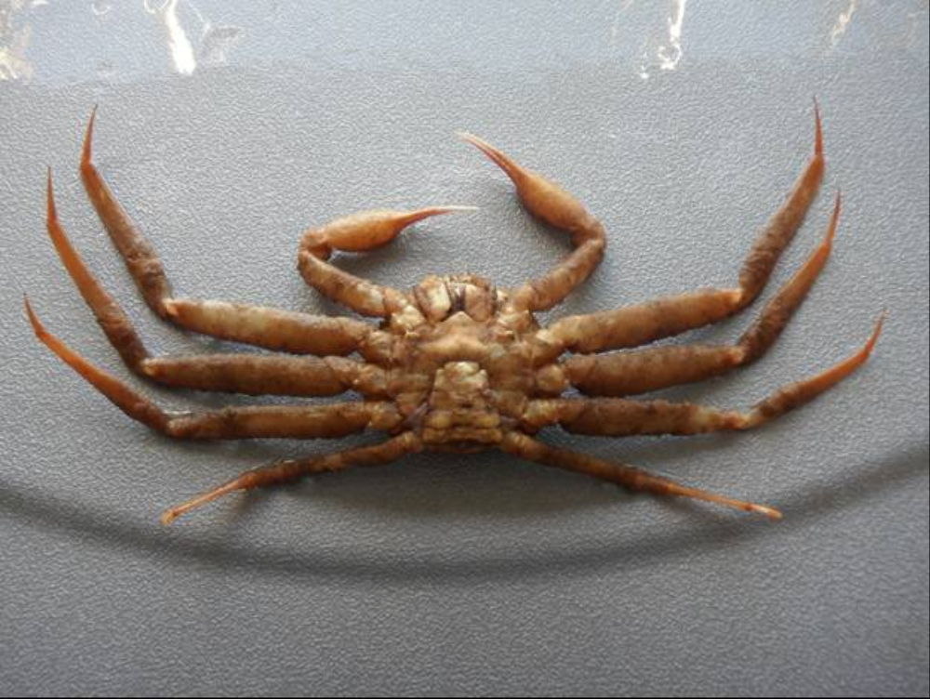
Appendix 4. Claw illustrations and location of durometer hardness measurement.

